Ref. No: CHEM/0016 Date: 15.09.2023

Notice Regarding Parents-Teacher Meeting
All the students of chemistry department are hereby notify that a Parent-Teacher’s meeting will be held on 29th September 2023 at 12-3 pm. On that day all students are requested to present the meeting with their parents in Departmental staff room within stipulated time. Students must inform their respective parents regarding the same. No excuse will be entertained. If anyone ignores then steps may be taken in future by the department. Time will be scheduled as:
1.5th Sem: 12-1 pm
2.2rd Sem: 1-2pm
3. 1st sem (major): 2-3 pm
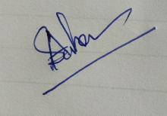
HOD
Department of Chemistry

